
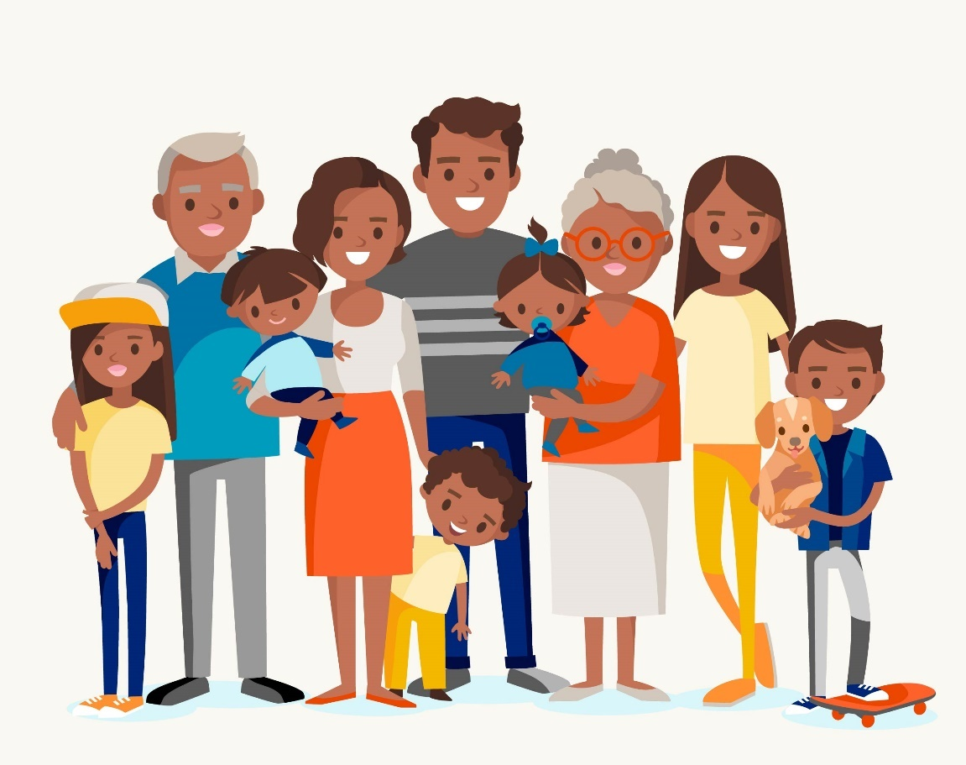
Caregiving in Multigenerational Families
Table of Contents
The program 2
Multigenerational family and caregiving 2
What is a multigenerational family? 2
Multigenerational family defined 3
Types of multigenerational households 3
What is the sandwich generation? 4
The sandwich generation 4
Boomerang children 5
Sandwich generation demographics 5
Sandwich generation statistics 6
Caregiving 7
Types of caregivers 8
Caregiving scenarios 9
Challenges associated with caregiving 10
Caregiving challenges 10
Self-care strategies for caregivers 12
The oxygen mask 12
Effects of caregiving on health and wellbeing 13
Self-care strategies 13
Take time for self-care 16
Emotional Wellbeing Solutions (EWS) 17
About Professional Support 17
Let’s reflect 18
References 19

The program

What is Mental Health?The Program
We will explore these key topics about caregiving in a multigenerational family:
Understand the concepts of multigenerational family and caregiving.

Identify challenges associated with caregiving in a multi-generational family and explore ways to address those challenges.

Learn self-care strategies for a caregiver.



Multigenerational family and caregiving

What is Mental Health?
What is a multigenerational family?

What is a multigenerational family?
Click here to enter your notes about what is a multigenerational family.

Multigenerational family defined
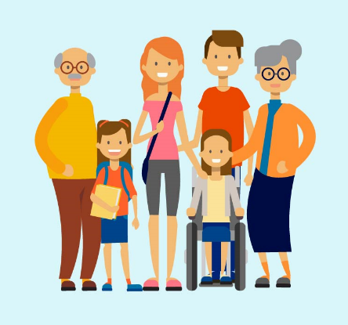
A multigenerational family is any home where two or more generations reside under one roof. This can range from an elderly couple living with their adult children and their grandchildren to homes where three, four, or five generations coexist. A multigenerational family may include great-grandparents, grandparents, parents, and children.
Types of multigenerational households
There are many different types and sizes of multigenerational households. Typical varieties include the following:
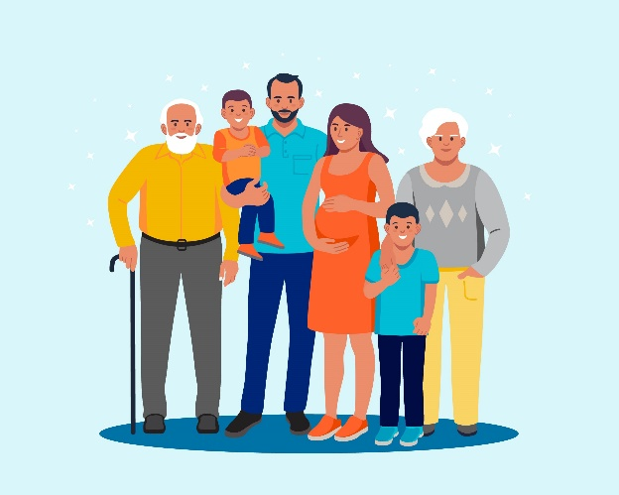
Three-generation family¹ – The most typical multigenerational household configuration consists of three generations: one or more working age adult, one or more of their children who can be adults, and either elderly parents or grandchildren.
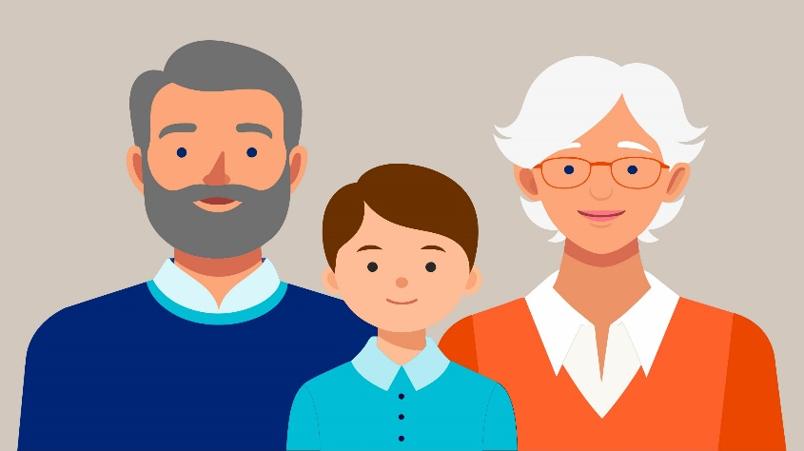
Grand or kinship family² – In this kind of household, children whose parents are unable to care for them are raised by grandparents, other adult relatives, or close friends.

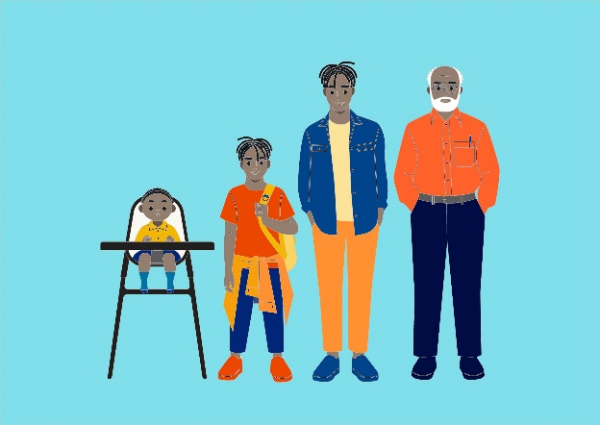
Two adult generations family¹ – The majority of two adult generation households are made up of a parent and a child or children who are younger than 18. This type of family can also include parents who move in with their adult children.
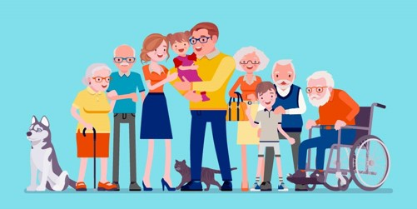
Four generation family¹ – Once a rarity except in some lower-income ethnic communities, the four- or even five-generation household – parents, grandparents, great-grandparents, adult children, their children – is more commonplace.

What is the sandwich generation?
What is the sandwich generation?
Click here to enter your notes about the sandwich generation.



The sandwich generation
The term "sandwich generation" describes middle-aged people who need to provide for their aging parents as well as their growing children³. The reason the sandwich generation got its name is that they are essentially "sandwiched" between having to take care of their elderly parents, who might be sick, incapable of doing certain daily activities, or in need of financial assistance, and their kids, who

need emotional, mental, and material support³. Part of the sandwich generation scenario can be attributed to trends in longer lifespans and later childbearing³. Increasing numbers of older adults are part of the sandwich generation, as younger adults struggle to establish a stable financial foundation and the elderly population rises⁴.

Boomerang children
It has become more commonplace for adult children to not only live at home but return home³. A phenomenon known as "boomerang children" occurs when an adult child, having lived independently for some time, returns home to live with their parents⁵. While the term “boomerang children” is an American term, descriptive terms have been used by other nations going through similar situations to identify the kids who stay at home or never leave.⁵ Boomerang kids frequently go back to live with their parents due to financial hardships like poor income, low savings, high debt, unemployment, or a worldwide financial crisis. Boomerang situations can also arise from family circumstances, such as divorce⁵.

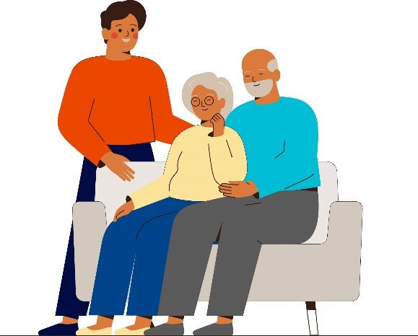

Sandwich generation demographics
With longer lifespans and people starting families later in life, the number of sandwich generation adults is rising. According to the article The sandwich generation on Senior Living, there are three roles those in the sandwich generation typically fall into⁴:

The traditional sandwich generation is people in their 40s or early 50s who are usually between their aging parents and their grown-up children, and who both require financial support or other forms of support.

The club sandwich generation are 50 and 60-year-olds who are sandwiched between their adult children, their aging parents, and potentially their grandchildren. This phrase can also be used to describe younger adults, in their 30s or 40s, who have older parents, grandparents, or younger children.




The open-faced sandwich generation applies to anyone who provides elder care in a non-professional capacity, estimated to be a quarter of people at some point in their lives.

Sandwich generation statistics
According to the article What is the Sandwich Generation? Unique Stress and Responsibilities for Caregivers Between Generations⁶:


Over 10% of adults who have a child under the age of 18 also look after their elderly parents.

Approximately three hours are dedicated to providing unpaid care by sandwich generation caregivers each day. Approximately 75% of them work full-time, meaning that's an additional 21 hours of caregiving per week on top of a 40-hour workweek.




Females make up about 60% of caregivers in the sandwich generation. Regardless of employment status, mothers devote approximately 45 minutes more per day to childcare than do male caregivers, but both genders spend roughly the same amount of time each day taking care of their elderly parents.


Sandwich generation caregivers spend an average of 86 minutes less a day on paid work.


Sandwich generation caregivers spend nearly a half hour less time sleeping every day.

Caregiving
Assisting someone else with daily tasks and activities is known as caregiving⁷. A family caregiver is a person who tends to a loved one who is ill, frequently without receiving official training or payment⁸. This role is played by people other than blood relatives and goes beyond the conventional notion of family. It can also be given by neighbors, friends, or anybody else who offers to take on the role of caregiver⁸. The following are some of the tasks that a caregiver might help with^{7 and 9}:

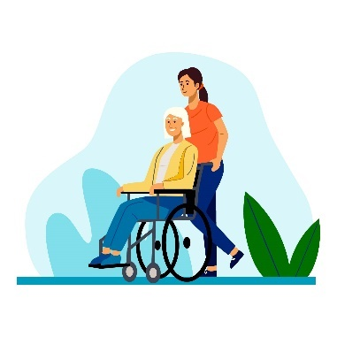
 | Personal care includes physical care such as dressing, bathing, grooming, using the toilet, and brushing teeth, and emotional care such as listening to, talking to, and giving reassurance.
 | Household tasks, such as shopping, laundry, cleaning, and yard work.
 | Preparing food, feeding, and monitoring dietary restrictions.
 | Health care, including talking to doctors, coordinating medical appointments, and keeping track of medications.
 | Transportation, such as car rides to appointments.
 | Financial and legal matters, such as paying bills, organizing important documents, and dealing with insurance companies, healthcare systems, and doctor’s offices.
“I like to say there are only four kinds of people in the world. Those who have been caregivers. Those who are currently caregivers. Those who will be caregivers, and those who will need caregivers.”
Rosalyn Carter – former First Lady of the United States

Types of caregivers
Different forms of caregivers exist, and each has a distinct relationship with the person receiving care. Although every kind of caregiver has a different viewpoint and faces distinct obstacles, they all aim to provide compassionate care. Several typical varieties include:


Crisis caregivers⁹
Click here to enter your notes about crisis caregivers.


Long-term caregivers⁹
Click here to enter your notes about long-term caregivers.


Long-distance caregivers⁹
Click here to enter your notes about long-distance caregivers.


Sandwiched caregivers⁹
Click here to enter your notes about sandwiched caregivers.

Spouse caregivers⁸
Click here to enter your notes about spouse caregivers.
Child caregivers⁸
Click here to enter your notes about child caregivers.

Parent caregivers⁸
Click here to enter your notes about parent caregivers.

Relative caregivers⁸
Click here to enter your notes about relative caregivers.

Friend or neighbor caregivers⁸
Click here to enter your notes about friend or neighbor caregivers.

Caregiving scenarios
Giving care is a commitment that takes many different forms and affects people at different phases of their health and wellbeing. As we have discussed, providing support to an individual undergoing health challenges, be they physical, mental, or emotional, is known as caregiving. The support provided can take many forms, including social, emotional, and practical help. Typical caregiving scenarios include, but are not limited to, the following⁸:

Caring for someone undergoing cancer treatment

Fulfill his or her potential.
Enter your notes about caring for someone undergoing cancer treatment.


Assisting someone who has been recently injured in an accident.

Fulfill his or her potential.
Enter your notes about assisting someone who has been injured in an accident.


Mental health caregiving

Fulfill his or her potential.
Enter your notes about mental health caregiving.


Supporting someone who is recovering from surgery

Fulfill his or her potential.
Enter your notes about supporting someone recovering from surgery.


Caring for a person with dementia

Fulfill his or her potential.
Enter your notes about caring for a person with dementia.

Challenges associated with caregiving

StatisticsWhat can lead to Mental Illness?
Caregiving challenges
Caregiving is a common duty. Around the world, countless individuals take care of their elderly parents, spouses, other family members, friends, children, and grandchildren. Nevertheless, despite the significance of the job, caregivers’ challenges are frequently disregarded.
  Time | When you're overwhelmed with everything, it can be hard to meet your own expectations. Whether you're a caregiver for a parent or a child, you may feel that you can't fulfill both roles. Perfection is unachievable, and there's only so much you can accomplish in one day.¹¹ The demands and difficulties of their job frequently result in high levels of stress for caregivers. Emotional and physical symptoms including headaches, exhaustion, agitation, anxiety, sadness, guilt, and grief can be a result of this.¹² | Click here to enter your notes about time.
  Family discord | Taking care of an elderly parent can be a stressful task. Siblings and other family members may want to get together during this period to support one another, but the change frequently elicits strong feelings. Disagreements concerning financial obligations and care decisions may arise with other family members.^{11 and 13} | Click here to enter your notes about family discord.
  Complex emotions | When you're overwhelmed with everything, it can be hard to meet your own expectations. Whether you're a caregiver for a parent or a child, you may feel that you can't fulfill both roles. Perfection is unachievable, and there's only so much you can accomplish in one day.¹¹ The demands and difficulties of their job frequently result in high levels of stress for caregivers. Emotional and physical symptoms including headaches, exhaustion, agitation, anxiety, sadness, guilt, and grief can be a result of this.¹² | Click here to enter your notes about complex emotions.
  Personal health | Providing care is a constant effort, no matter how easy or difficult it is for you. Every single day, month after month, or even year after year, it can be taxing and result in physical health issues as well as emotional exhaustion. As a matter of fact, some caregivers become so ill physically that they are in worse physical condition than the individuals they are caring for.¹³ | Click here to enter your notes about personal health.
  Sleep deprivation | Due to the mental and physical strains of their work, as well as the difficulties in juggling caregiving with other responsibilities, caregivers may suffer from sleep deprivation. Getting enough sleep is essential, so caregivers must figure out how to get enough of it.¹² | Click here to enter your notes about sleep deprivation.
  Lack of privacy | Since they spend so much time near the people they are caring for, caregivers frequently struggle to maintain a sense of privacy.¹⁴ Since they are at home to provide care, it can be difficult to have time for themselves with other family members around. Because it can be difficult to avoid constant interactions, it is nearly impossible to establish personal boundaries.¹² | Click here to enter your notes about lack of privacy.
  Asking for help | Another significant barrier in providing care is the idea of asking for assistance. Most caregivers find it embarrassing to ask for help from relatives. They believe that providing care is entirely their responsibility and that asking for help is a sign of weakness. They may feel guilty as a result, which may make them feel unfit to give care.¹⁴ | Click here to enter your notes about asking for help.
  Financial challenges | Life becomes costly very quickly, and there is frequently not enough money for everything. Due to the numerous additional costs, this frequently gets worse when you are providing care. Your financial issues cannot be solved with a magic wand. Nevertheless, there is assistance available as well as methods that can simplify life.¹³ | Click here to enter your notes about financial challenges.

Self-care strategies for caregivers

StatisticsWhat can lead to Mental Illness?
The oxygen mask¹⁵
An oxygen mask lowers in front of you on an airplane. What do you do? It is common knowledge that you should put your oxygen mask on before helping someone else. We can only effectively help others when we first help ourselves. One of the most significant, and frequently overlooked, things a caregiver can do is

take care of themselves. The person you are caring for will gain when your needs are met.

Effects of caregiving on health and wellbeing
 | 
Health and wellbeing | Signs of stress
Compared to non-caregivers, family caregivers of any age are less likely to engage in preventive healthcare and self-care practices. Caregivers report difficulties balancing their own health and wellbeing with their caregiving responsibilities, regardless of age, sex, race, or ethnicity. Family caregivers report¹⁵: | Individuals in caregiving roles frequently devote so much of their time to helping and supporting others that they neglect their own needs, sometimes without even realizing it. Caretakers frequently neglect to take care of themselves because they are too preoccupied tending to the needs of others. Stress in caregivers can manifest as¹⁶:
- Sleep deprivation  - Poor eating habits  - Failure to exercise  - Failure to stay in bed when ill  - Failure to make medical appointments  - Depression  - Substance misuse  - Chronic illness | - Anxiety or feeling worried  - Difficulty sleeping  - Exhaustion  - Hopelessness  - Irritability  - Withdrawing from people and activities once loved  - Headaches  - Weakened immune system  - Raised blood pressure  - Feeling nauseated  - Aches and pains

Self-care strategies
Even the most resilient person can become exhausted from the mental and physical strain of providing care. You can start altering your behavior as soon as you've begun to recognize any personal obstacles to practicing good self-care. Let’s explore some self-care strategies:

  Reduce personal stress | Your perspective of the situation—whether you see it as half-full or half-empty—as well as your caregiving circumstances contribute to the stress you experience. It's critical to keep in mind that you are not alone. Numerous factors, affect your stress including if it is your choice to provide care, your connection to the care recipient, the way you relate to the person receiving care, your capacity for coping, and how readily assistance is available.¹⁵ | Click here to enter your notes about reducing personal stress.
  Set goals | One of the most important tools for taking care of yourself is setting goals or determining what you need and want to accomplish. Divide complicated jobs into manageable chunks that you can finish one at a time. Make a list of the priorities. Adhere to a daily schedule. Refuse requests that drain you. You may occasionally feel that you are not making enough progress. However, nobody makes a perfect caregiver. Remember that you're putting forth your best effort.^{15 and 17} | Click here to enter your notes about setting goals.
  Talk to your physician | Caregivers seldom talk about their own health. Building a partnership with a physician that addresses the health needs of you the caregiver is crucial. When scheduling an appointment with your healthcare provider make sure the appointment meets your needs. Be sure to schedule your appointment for when you have time and when you think you will spend the least amount of time waiting, like the first appointment in the morning or right after lunch. Prepare for your appointment by writing down the questions you have, and the health concerns you want to discuss with your physician. This will help your physician get the complete picture of what is going on in your life and make the most effective use of your physicians’ time. The key is to communicate with your physician. Make sure they understand and address your concerns.¹⁵ | Click here to enter your notes about talking to your physician.
  Communicate | For a caregiver, one of the most vital skills is effective communication. Your communication will be heard, and you will receive the assistance and support you require if you are clear, assertive, and constructive. Asking for assistance can be difficult for many caregivers because they don't know how to gather support from others. Perhaps you don't want to put people through unnecessary hardship or acknowledge that you can't do it all. Acknowledging your need for assistance can be difficult. In addition, remember that people are always willing to lend a helping hand, all you have to do is ask.^{15, 16, and 17} | Click here to enter your notes about communicating.
  Look for support | When caregiving is left to one person, it can be a lonely and alienating experience. Consider any potential community resources, particularly if you don't have a strong support network. Support groups, both online and in person, help you meet others who are dealing with comparable challenges when providing care. They can make you feel more understood and less alone. Maintaining social connections with friends and family is crucial to feeling less alone and avoiding burnout, even though it can be challenging to schedule social events while caring for others. ^{16, 17, and 18} | Click here to enter your notes about sleep looking for support.

Take time for self-care

Self-care is how you can help care for your mental health. Self-care means taking time to do the things that help you live your best life and improve both your physical and mental health. So, what can you do to practice self-care to help care for your mental health:


Get regular exercise (consult a physician prior to beginning to exercise).¹⁹


Eat healthy and stay hydrated.¹⁹


Make sleep a priority.¹⁹


Take up a relaxing activity.¹⁹


Practice gratitude – take time to think about what you are grateful for every day.¹⁹


Focus on positivity.¹⁹


Breathing exercise – Get into a comfortable position. Place the tip of your tongue against the tissue behind your upper front teeth. Slowly inhale through your nose to a mental count of 4. Hold your breath for a mental count of 7. Exhale – making a “whoosh” sound – through your mouth to a mental count of 8. Repeat the exercise for 4 breath cycles, twice per day.²⁰

Emotional Wellbeing Solutions (EWS)
- Short term counselling and support for all employees and immediate family members (if eligible).

- Provided at no cost to you by your employer.

- Easily accessible, voluntary, and confidential in accordance with the law – service that can provide support for personal or work-related issues.

- Staffed by experienced professionals.

“This program should not be used for emergency or urgent care, call the local emergency services phone number, or go to the nearest emergency room. This program is not a substitute for a doctor’s or professional’s care. Due to the potential for a conflict of interest, legal consultation will not be provided on issues that may involve legal action against Optum or its affiliates, or any entity through which the caller is receiving these services directly (e.g., employer). This program and its components may not be available in all locations or for all group sizes and is subject to change. Coverage exclusions and limitations may apply. The EWS information in this training is only applicable to eligible members in attendance.”

About professional support
You may consider seeking professional support if you experience any of the following:
- Sleep problems.

- Performance issues at work.

- Relationship difficulties with family or friends.

- Loss of interest in hobbies you normally enjoy.

- Lack of care about normal everyday work tasks.

- Excessive anxiety or worrying more than normal.

- Feeling overwhelmed or sad for more than two weeks.

- A noticeable change in appetite, eating too little or too much.

- Behavior and coping methods have become harmful to yourself
or others, whether that is through aggressive behavior or unhealthy habits, such as drinking too much alcohol or taking drugs.

- Thoughts of harm to self and/or others.

Keep in mind some of these conditions may warrant more urgent professional help and you should seek support if you are unsure.

Your Emotional Wellbeing Solutions (EWS) is available to all employees and their covered dependents and may include some free counseling sessions per issue, per year. Please check with your employer or your health plan for details.

Let’s reflect
Take some time to answer the questions below using the “Enter text here” boxes provided to record your answers.

- What is one thing that you have learned from this session?
Enter text here.
- What is one thing that you would like to research more?
Enter text here.

- What is one thing that you will do if you become a caregiver in your family?
Enter text here.

References
¹Generations United. (n.d.). Multigenerational households - generations united. https://www.gu.org/explore-our-topics/multigenerational-households/. Accessed 1 May 2024.
²Generations United. (n.d.-a). Grandfamilies - generations united. https://www.gu.org/explore-our-topics/grandfamilies/. Accessed 1 May 2024.
³Kenton, W. (17 July 2022). Sandwich Generation: What the term means, how to manage. Investopedia. https://www.investopedia.com/terms/s/sandwichgeneration.asp. Accessed 2 May 2024.
⁴Hoyt, J. (29 January 2024). The sandwich generation. SeniorLiving.org. https://www.seniorliving.org/caregiving/sandwich-generation/. Accessed 2 May 2024.
⁵Hayes, A. (13 March 2022). Boomerang Children: meaning, impact, around the world. Investopedia. https://www.investopedia.com/terms/b/boomerangs.asp. Accessed 2 May 2024.
⁶Samuels, C. (7 July 2020b). What is the Sandwich Generation? Unique Stress and Responsibilities for Caregivers Between Generations. https://www.aplaceformom.com/caregiver-resources/articles/what-is-the-sandwich-generation. Accessed 6 May 2024.
⁷Getting started with Caregiving. (n.d.). National Institute on Aging. https://www.nia.nih.gov/health/caregiving/getting-started-caregiving. Accessed 7 May 2024.
⁸Staff, C. (20 February 2024). What is a family caregiver? definition, resources and more. CaringBridge. https://www.caringbridge.org/resources/what-is-a-family-caregiver/. Accessed 22 April 2024.
⁹CaringInfo. (11 August 2022). What is “Caregiving”? - CaringInfo. https://www.caringinfo.org/planning/caregiving/what-is-caregiving/. Accessed 7 May 2024.
¹⁰Beabout, L. (14 March 2022). 16 Caregiver Quotes for Inspiration and Encouragement. The Healthy – A Reader’s Digest Brand. https://www.thehealthy.com/healthcare/caregiving/caregiver-quotes/. Accessed 7 May 2024.
¹¹Caregiving and the sandwich generation. (n.d.-b). Mental Health America. https://www.mhanational.org/caregiving-and-sandwich-generation. Accessed 8 May 2024.
¹²Nasir, M. (21 June 2023). Overcoming Caregiver Issues: 14 Common challenges and Effective solutions. ConsidraCare. https://www.considracare.com/overcoming-caregiver-issues-14-common-challenges-and-effective-solutions/. Accessed 8 May 2024.
¹³MSc, C. G. (24 October 2022). 12 Tough challenges faced by caregivers and how to overcome them. Kapok Aging and Caregiver Resources. https://multiculturalcaregiving.com/challenges-faced-by-caregivers/. Accessed 8 May 2024.
¹⁴Calderon, C. (1 August 2023). Caregiver issues: challenges affecting caregivers and how to cope. Women’s Health Blog. https://womenshealthblog.org/caregiver-issues-challenges/. Accessed 8 May 2024.
¹⁵Taking Care of YOU: Self-Care for Family Caregivers - Family Caregiver Alliance. (11 January 2023). Family Caregiver Alliance. https://www.caregiver.org/resource/taking-care-you-self-care-family-caregivers/. Accessed 9 May 2024.
¹⁶Clinic, C. (19 March 2024a). Self-Care tips for caregivers: Your health matters, too. Cleveland Clinic. https://health.clevelandclinic.org/self-care-for-caregivers. Accessed 9 May 2024.
¹⁷Caregiver stress: Tips for taking care of yourself. (9 August 2023). Mayo Clinic. https://www.mayoclinic.org/healthy-lifestyle/stress-management/in-depth/caregiver-stress/art-20044784. Accessed 9 May 2024.
¹⁸LeWine, R. B. H., MD. (24 January 2024). Self-care for the caregiver. Harvard Health. https://www.health.harvard.edu/blog/self-care-for-the-caregiver-2018101715003. Accessed 9 May 2024.
¹⁹Caring for your mental health. (n.d.). National Institute of Mental Health (NIMH). https://www.nimh.nih.gov/health/topics/caring-for-your-mental-health. Accessed 9 May 2024.
²⁰Bulzoni, S. (22 Feb. 2022). Breathing exercises: Three to try: 4-7-8 breath. DrWeil.com. https://www.drweil.com/health-wellness/body-mind-spirit/stress-anxiety/breathing-three-exercises/. Accessed 9 May 2024.

