

Psychological Safety
Table of Contents
The program 2
Psychological safety overview 2
What is psychological safety? 2
Key elements of psychological safety 3
What psychological safety is not 4
Psychological safety – myth or fact 4
Why psychological safety is critical in the workplace 5
Psychological safety across different workplace settings 6
Four stages of psychological safety 6
Inclusion safety 7
Learner safety 8
Contributor safety 8
Challenger safety 9
Psychological safety and toxic positivity 10
Psychological versus toxic positivity 10
Balancing psychological safety and toxic positivity 11
Strategies to foster psychological safety 12
Psychological safety in the workplace 12
Creating a psychologically safe workplace 13
Emotional Wellbeing Solutions (EWS) 14
About Professional Support 14
Let’s reflect 15
References 16

The program

What is Mental Health?The Program
We will discuss these key topics about psychological safety:
Define psychological safety and determine why it is important in the workplace.

Identify common misconceptions about psychological safety.

Explore the four stages of psychological safety.

Discover the link between psychological safety and toxic positivity.

Identify actionable strategies to foster psychological safety.



Psychological safety overview

What is Mental Health?
What is psychological safety?


What is psychological safety?
Click here to enter your notes about what is psychological safety.


“Psychological safety is the belief that one can express ideas, admit mistakes, and take risks without fear of punishment, humiliation, or negative consequences.”¹
Psychological safety allows team members to make mistakes and share bad news without fear, fostering trust and mutual respect. This supportive environment empowers individuals to contribute openly, collaborate across perspectives, and enhances the team’s ability to innovate, solve problems, and adapt to change.²

In a psychologically safe team, members feel free to speak openly, share ideas, admit mistakes, and give honest feedback, regardless of rank. This environment encourages curiosity over criticism, allowing for bold ideas and constructive conversations, even with leadership. Feedback is specific and balanced, fostering trust, learning, and collaboration.²

Key elements of psychological safety

Creating a culture of psychological safety is essential for high-performing, resilient teams. When open communication is encouraged, and individuals feel safe to take risks, innovation and growth thrive. Mutual respect and supportive leadership lay the foundation for a learning culture where feedback is valued, and mistakes are seen as opportunities.
The key elements of psychological safety are¹:

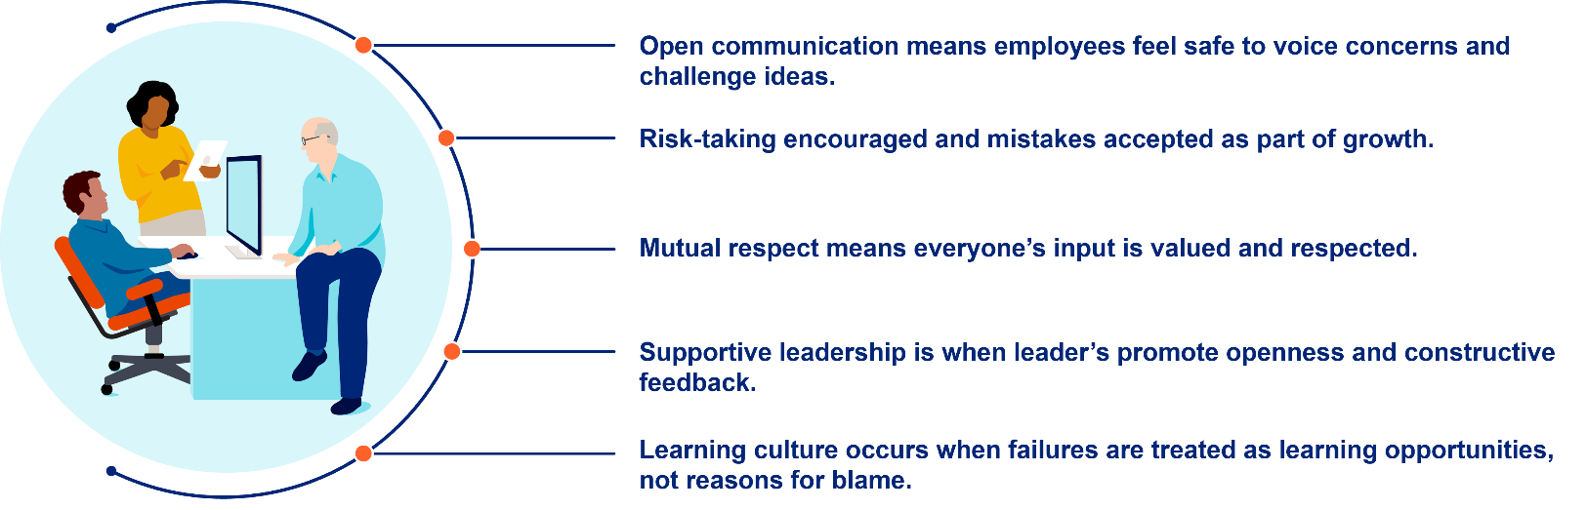

What psychological safety is not

Psychological safety is often misunderstood.


It’s not about steering clear of disagreements or withholding constructive feedback.³


It doesn’t involve compromising on quality or accepting subpar performance.³


It’s not about ensuring constant comfort; healthy debate and tough conversations are still part of a psychologically safe environment.³

In fact, a psychologically safe environment embraces respectful debate, honest conversations, and high standards. It’s about fostering a culture where people feel secure enough to speak up, challenge ideas, and grow, even when it’s uncomfortable.

Psychological safety – myth or fact

While psychological safety is essential for healthy team dynamics, it’s often misunderstood. Many believe it means avoiding conflict, lowering standards, or ensuring constant comfort—but that’s not the case. True psychological safety supports honest feedback, high performance, and respectful disagreement.
Let’s explore and clarify some of the most common misconceptions to better understand what psychological safety really involves.
Being nice all the time³ | Click here to enter your notes about being nice all the time.
Lowers performance standards³ | Click here to enter your notes about lowering performance standards.
Eliminates all discomfort at work³ | Click here to enter your notes about eliminating all discomfort at work.
There are no hierarchies or leadership roles³ | Click here to enter your notes about no hierarchies or leadership roles.
Everyone agrees all the time³ | Click here to enter your notes about everyone agreeing all the time.
Only about protecting employees’ feelings³ | Click here to enter your notes about protecting employees’ feelings.
Soft skill with no real business impact³ | Click here to enter your notes about being a soft skill with no real business impact.
Happens automatically³ | Click here to enter your notes about happening automatically.

Why psychological safety is critical in the workplace
Psychological safety is the shared belief that it's safe to take interpersonal risks at work. It exists at both individual and team levels and is essential for learning, collaboration, and performance. Without it, employees may avoid risks, hide mistakes, or conform to the status quo—behaviors that hinder innovation. When psychological safety is present, people feel empowered to speak up, share ideas, and take initiative, driving team success.⁴



 | Boosts innovation and creativity¹ | Click here to enter your notes about boosting innovation and creativity.
 | Improves employee engagement and retention¹ | Click here to enter your notes about improving employee engagement and retention.
 | Enhances collaboration and team performance¹ | Click here to enter your notes about enhancing collaboration and team performance.
 | Reduces workplace stress and burnout¹ | Click here to enter your notes about reducing workplace stress and burnout.
 | Encourages learning and growth¹ | Click here to enter your notes about encouraging learning and growth.
 | Increased diversity in the workplace² | Click here to enter your notes about increased diversity in the workplace.

Psychological safety across different workplace settings

Psychological safety must be cultivated across all work environments, not just in traditional offices. Remote teams, field operations, and global offices each face distinct challenges in building open, trusting cultures, making intentional efforts essential in every setting.

 | 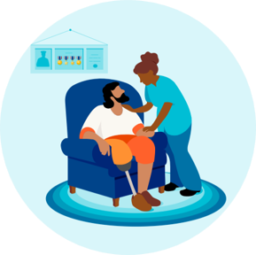 | 
Remote teams⁵ | Fieldwork⁵ | Global offices⁵
Hold regular virtual check-ins and provide digital spaces where team members can share both professional updates and personal experiences or challenges. | Incorporate safety briefings that cover both physical and behavioral safety practices, encouraging team members to speak up about any concerns related to their wellbeing, both physical and psychological. | Consider local cultural values and customs when designing psychological safety initiatives to ensure they are meaningful and effective in each context.

Psychological safety is the foundation of a healthy, high-performing team culture. The four stages of psychological safety represent the progressive steps individuals experience as they feel increasingly secure to contribute, challenge, and grow within a group. Understanding these stages helps you foster an environment where everyone feels valued and empowered. By recognizing and supporting each stage, workplaces can build stronger collaboration, innovation, and trust across teams.⁶

Four stages of psychological safety

What is Mental Health?The Program
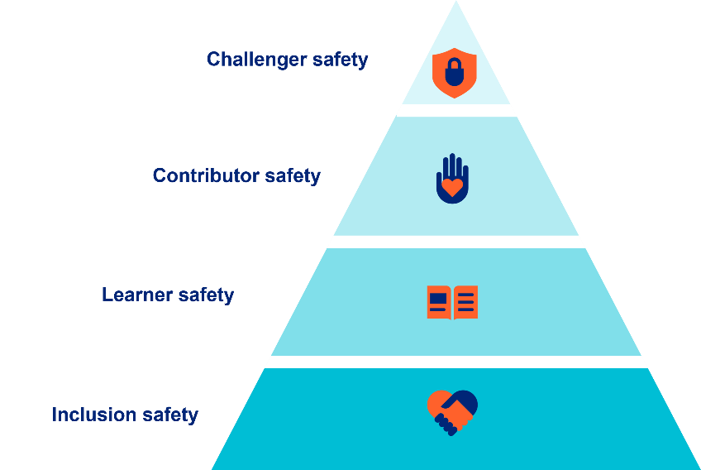

Inclusion safety
The first stage of psychological safety is inclusion safety, which fulfills the fundamental human need to belong. It ensures individuals feel accepted, respected, and valued within a team, allowing them to engage without fear of rejection or embarrassment. This stage fosters open communication and authentic collaboration by creating a welcoming and supportive environment. Leaders play a key role by promoting diversity, equity, and addressing bias, laying the foundation for trust and team success. ^{6 and 7}



How is inclusion safety strengthened? ⁸
- Foster diversity and fairness – Representation is powerful. When employees observe diverse leadership and teams, it reinforces their sense of inclusion.
- Practice inclusive listening – It's essential that all employees feel heard. Leaders should try to gather input from everyone, not just the most outspoken voices.
- Minimize bias in decisions – Both conscious and unconscious biases can limit opportunities for some individuals. Implementing structured approaches in hiring, promotions, and daily decisions can help ensure fairness.
- Embrace uniqueness – Valuing the diverse backgrounds, experiences, and viewpoints of team members nurtures a culture of respect and belonging.
Learner safety
The second stage of psychological safety is learner safety, which supports individual and team growth by fostering an environment where people feel safe to ask questions, experiment, and make mistakes. This stage encourages curiosity, feedback, and risk-taking, all key ingredients for innovation and continuous improvement. When learner safety is present, individuals are less likely to self-censor and more


likely to contribute ideas and seek development. Leaders play a vital role by modeling humility, encouraging open dialogue, and creating a culture where learning is both supported by the organization and actively pursued by team members.^{6 and 7}

How is learner safety enhanced? ⁸
- Promote open feedback – Create an environment where employees feel safe to both give and receive feedback without fear of negative consequences.
- View mistakes as growth opportunities – Rather than assigning blame, leaders should treat errors as chances for learning and development.
- Support ongoing development – Providing access to training, mentorship, and learning resources demonstrates a commitment to continuous improvement.
- Lead by example – When leaders openly acknowledge their own learning journeys and admit when they don’t have all the answers, it encourages employees to do the same.

Contributor safety

The third stage of psychological safety is contributor safety, which fulfills the need to make a meaningful impact within a team or community. At this stage, individuals feel trusted, empowered, and supported to contribute their ideas, skills, and efforts toward shared goals. When team members are recognized for their contributions and given autonomy, they are more likely to engage, innovate, and perform at a high level. Leaders play a key role by fostering a culture of trust, accountability, and inclusion, ensuring everyone can participate and be heard.^{6 and 7}

How is contributor safety reinforced? ⁸
- Empower employees with independence – Allowing team members to take charge of their work fosters confidence and drives motivation.
- Acknowledge and celebrate contributions – Recognizing employees’ efforts through praise, rewards, or growth opportunities reinforces their value and encourages continued engagement.
- Build mutual trust through respect – Establishing an unspoken understanding that employees can speak up without fear helps create a foundation of trust.
- Welcome a range of viewpoints – Leaders should actively seek out and consider diverse perspectives to ensure all voices are heard and valued.

Challenger safety
The fourth and final stage of psychological safety is challenger safety, which empowers individuals to question the status quo and drive positive change. At this level, team members feel safe expressing dissenting views, offering candid feedback, and engaging in constructive conflict—all which fuel innovation and continuous improvement. Achieving challenger safety requires a culture that sets high expectations while providing the support and openness needed for honest dialogue. Leaders must model emotional maturity, welcome challenge without defensiveness, and ensure that all voices are


respected. When done well, this stage transforms teams into fearless, high-performing units capable of breakthrough success.^{6 and 7}

How is challenger safety built? ⁸
- Promote constructive dialogue – Encourage employees to challenge ideas respectfully and with a focus on finding solutions.
- Foster openness to questioning leadership – Team members should feel safe raising concerns or offering alternative views without fear of retaliation. Leaders must respond with curiosity and openness, not defensiveness.
- Follow through on employee input – When suggestions are consistently ignored, employees may disengage. Implement clear processes to review and act on feedback meaningfully.
- Equip leaders to welcome dissent – Train leaders to see differing opinions not as threats, but as valuable opportunities for learning and growth.

Psychological safety and toxic positivity

What is Mental Health?The Program

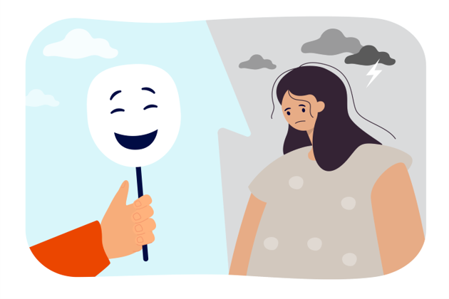
Psychological safety and toxic positivity are two concepts often discussed in the context of workplace dynamics. They represent different aspects of how employees feel and interact within their professional environment. Understanding the connection between these two can help in creating a more balanced and healthier workplace.

likely to contribute ideas and seek development. Leaders play a vital role by modeling humility, encouraging open dialogue, and creating a culture where learning is both supported by the organization and actively pursued by team members.^{6 and 7}

Psychological safety in the workplace
As has been discussed psychological safety is the belief that one can speak up without fear of punishment or humiliation. It fosters open communication, innovation, and teamwork by encouraging employees to share ideas and concerns freely.
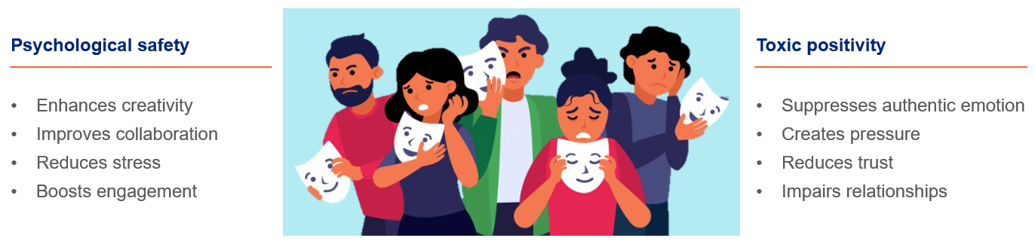
Psychological safety is important because it enhances creativity, improves collaboration, reduces stress, and boosts engagement. In a psychologically safe workplace employees are more likely to propose new ideas because they don’t fear ridicule, because the anxiety related to making mistakes has been mitigated. Team members feel comfortable sharing information and asking for help. Employees are also more invested in their work and the organization's goals. ^{12, 3, 13, and 14}

Toxic positivity, on the other hand, refers to the excessive and ineffective overgeneralization of a happy, optimistic state across all situations. It can invalidate genuine emotions and discourage individuals from expressing their true feelings. While positivity is generally beneficial, when it becomes toxic, it can lead to a suppression of authentic emotional experiences and create a disconnect among team members. ^{12, 3, 13, and 14}

Toxic positivity negatively effects the workplace by suppressing authentic emotions, creating pressure, reducing trust, and impairing relationships. In a workplace with toxic positivity employees hide their true feelings and impose unrealistic expectations to always remain positive. Employees may also feel as if their concerns are not taken seriously. All of this contributes to impaired relationships because genuine connections are hindered when individuals cannot express vulnerability. ^{12, 3, 13, and 14}

Balancing psychological safety and toxic positivity
While psychological safety and toxic positivity may seem like opposites, they are intricately linked. Psychological safety involves creating an environment where individuals feel safe to express their true emotions, including negative ones. Toxic positivity undermines psychological safety by promoting a culture where only positive emotions are accepted, leading to a lack of authenticity and trust.

Finding the balance between promoting positive thinking and ensuring psychological safety is vital for a healthy workplace. This balance can be found by^{12, 3, 13, and 14}:
- Encouraging authenticity by allowing everyone to express a range of emotions.
- Validating experiences by acknowledging and addressing genuine concerns.
- Providing support by offering resources for mental health and wellbeing.
- Promoting open communication by creating channels where everyone can freely share their thoughts.


Understanding the link between psychological safety and toxic positivity is crucial for fostering a healthy workplace environment. By promoting authenticity, validating employees' experiences, and balancing positive thinking with genuine emotional expression, workplaces can ensure that their teams are both psychologically safe and genuinely positive. This balance leads to higher engagement, better collaboration, and overall improved wellbeing for all members of the organization.

Strategies to foster psychological safety

What is Mental Health?

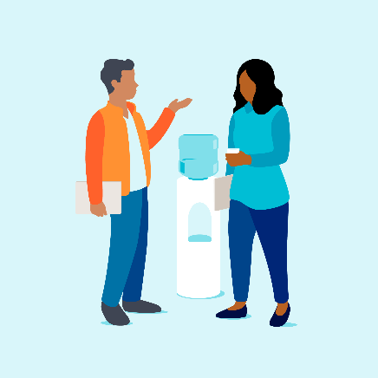
What is psychological safety in the workplace?
Click here to enter your notes about what is psychological safety in the workplace.

Psychological safety in the workplace
Psychological safety is not a quick fix. It’s a continuous, intentional process rooted in trust, open communication, and a strong, values-driven culture. It begins with clearly defining and consistently upholding your organization’s core values. Without alignment between stated values and daily actions, progress toward psychological safety stalls. Building this environment means encouraging vulnerability, actively listening, and rewarding authentic participation. Over time, these efforts create a culture where people feel safe to speak up, take risks, and grow together.⁶

Creating a psychologically safe workplace
It is important to remember that you contribute to setting the tone in your workplace. A key factor in promoting psychological safety is modeling behaviors like admitting your own mistakes and exhibiting vulnerability.⁹
Some strategies to help build a psychologically safe workplace include:
 | Build trust¹¹ | Click here to enter your notes about building trust.
 | Communication and listening^{9 and 11} | Click here to enter your notes about communicating and listening.
 | Diversity, equity, and inclusion¹⁰ | Click here to enter your notes about diversity, equity, and inclusion.
 | Continually improve^{9 and 10} | Click here to enter your notes about continual improvement.
 | Create a safe environment¹¹ | Click here to enter your notes about creating a safe environment.
 | Develop an open mindset¹¹ | Click here to enter your notes about developing an open mindset.

Emotional Wellbeing Solutions (EWS)
- Short term counselling and support for all employees and immediate family members (if eligible).

- Provided at no cost to you by your employer.

- Easily accessible, voluntary, and confidential in accordance with the law – a service that can provide support for personal or work-related issues.

- Staffed by experienced professionals.

“This program should not be used for emergency or urgent care, call the local emergency services phone number, or go to the nearest emergency room. This program is not a substitute for a doctor’s or professional’s care. Due to the potential for a conflict of interest, legal consultation will not be provided on issues that may involve legal action against Optum or its affiliates, or any entity through which the caller is receiving these services directly (e.g., employer). This program and its components may not be available in all locations or for all group sizes and is subject to change. Coverage exclusions and limitations may apply. The EWS information in this training is only applicable to eligible members in attendance.”

About professional support
You may consider seeking professional support if you experience any of the following:
- Sleep problems.

- Performance issues at work.

- Relationship difficulties with family or friends.

- Loss of interest in hobbies you normally enjoy.

- Lack of care about normal everyday work tasks.

- Excessive anxiety or worrying more than normal.

- Feeling overwhelmed or sad for more than two weeks.

- A noticeable change in appetite, eating too little or too much.

- Behavior and coping methods have become harmful to yourself
or others, whether that is through aggressive behavior or unhealthy habits, such as drinking too much alcohol or taking drugs.

- Thoughts of harm to self and/or others.

Keep in mind some of these conditions may warrant more urgent professional help and you should seek support if you are unsure.

Your Emotional Wellbeing Solutions (EWS) is available to all employees and their covered dependents and may include some free counseling sessions per issue, per year. Please check with your employer or your health plan for details.

Let’s reflect
Take some time to answer the questions below using the “Enter text here” boxes provided to record your answers.
- What is one thing you have learned?
Enter text here.
- What is one thing you would like more research on?
Enter text here.

- What is one thing you will do to help create psychological safety in the workplace?
Enter text here.

References
¹Admin. (22 February 2025). What Does Psychological Safety Mean at the Workplace? - HSE STUDY GUIDE. HSE STUDY GUIDE. https://www.hsestudyguide.com/psychological-safety/. Accessed 19 May 2025.
²Staff, C. (2025). Understanding Psychological Safety: Why It Matters and How to Create It. Coursera. https://www.coursera.org/articles/psychological-safety?msockid=0f2fd10e128664ce06bac2791367653c. Accessed 19 May 2025.
³What People Get Wrong About Psychological Safety. (May 2025). Harvard Business Review. https://hbr.org/2025/05/what-people-get-wrong-about-psychological-safety. Accessed 19 May 2025.
⁴Gardiner, K. (21 September 2023). Psychological Safety & Positive Psychology: a Leadership Guide. PositivePsychology.com. https://positivepsychology.com/psychological-safety/. Accessed 19 May 2025.
⁵Toke, N. (26 April 2024). What is Psychological Safety and Its Impact in the Workplace? Diversity.social; Diversity.Social Diversity and Inclusion News. https://diversity.social/what-is-psychological-safety-and-how-it-works/. Accessed 19 May 2025.
⁶McCann, A. (13 April 2023). Establishing the 4 stages of psychological safety in the workplace. The Predictive Index. https://www.predictiveindex.com/blog/4-stages-psychological-safety/. Accessed 20 May 2025.
⁷OMT Global. (4 April 2024). 4 STAGES OF PSYCHOLOGICAL SAFETY - OMT Global. OMT Global. https://omtglobal.com/4-stages-of-psychological-safety/. Accessed 20 May 2025.
⁸Lyon, S. (3 March 2025). People Insight. People Insight. https://peopleinsight.co.uk/4-stages-of-psychological-safety/. Accessed 20 May 2025.
⁹Kennedy, J. (8 September 2023). Creating Psychological Safety int the Workplace. Psychology Today. https://www.psychologytoday.com/us/blog/brain-reboot/202309/creating-psychological-safety-in-the-workplace. Accessed 20 May 2025.
¹⁰Ravishankar, R. A. (1 December 2022). A guide to building psychological safety on your team. Harvard Business Review. https://hbr.org/2022/12/a-guide-to-building-psychological-safety-on-your-team. Accessed 20 May 2025.
¹¹Psychological safety: the key to worker happiness and team productivity -- Occupational Health & Safety. (4 February 2020). Occupational Health & Safety. https://ohsonline.com/articles/2020/02/04/psychological-safety-the-key-to-worker-happiness-and-team-productivity.aspx. Accessed 20 May 2025.
¹²Cote, C. (28 March 2024). How to Build a Psychologically Safe Workplace. Business Insights Blog. https://online.hbs.edu/blog/post/psychological-safety-in-the-workplace. Accessed 12 June 2025.
¹³The Downside of Psychological Safety in the Workplace. (n.d.). Knowledge at Wharton. https://knowledge.wharton.upenn.edu/article/the-downside-of-psychological-safety-in-the-workplace/. Accessed 12 June 2025.
¹⁴Cherry, K. (1 February 2021). Why Toxic Positivity Can Be So Harmful. Verywell Mind. https://www.verywellmind.com/what-is-toxic-positivity-5093958. Accessed 12 June 2025.

